Project 1 Analysis and Conclusion

Our group chose to do our first project over FAANG stocks and the correlations they have on stock prices, trading volume, inflation rates, and treasury interest rates. With this in mind, we came up with four questions as follows:

1. What is the relationship between stock prices and time?
2. How does Treasury interest rate changes affect stock prices during 2022?
3. How does the inflation rate correlate with stock trading volume during 2022?
4. Which stock appear to be the best investment insofar as performance?

We measured stock price for the year of 2022 for all five FAANG stocks versus time. We discovered that all five FAANG stock prices decreased from the price they started at the beginning of the year, Facebook performed the lowest and apple the highest in terms of stock price at the end of the year. Apple’s stock price decreased 27% by the end of the year and Facebook’s decreased by 67%. We concluded that FAANG stock prices versus time have a direct relationship with a negative slope during 2022. This negative slope indicates a negative rate of change for the year. See figures 1 and 2 below.

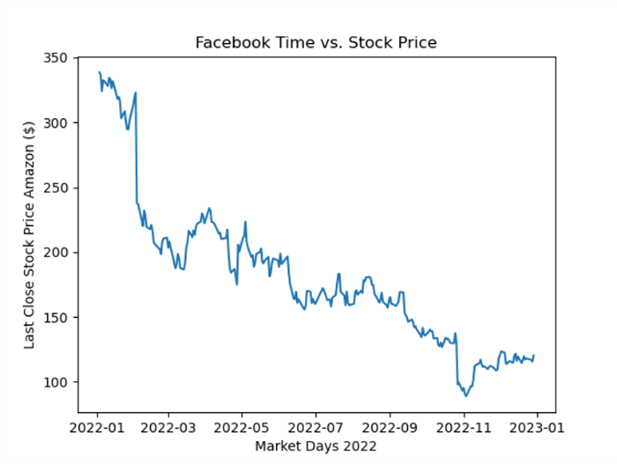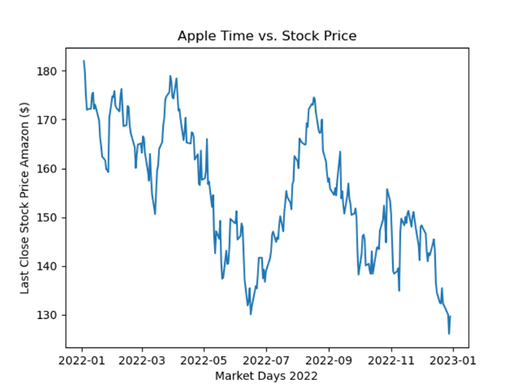

Figure 1

Figure 2

Figure 1

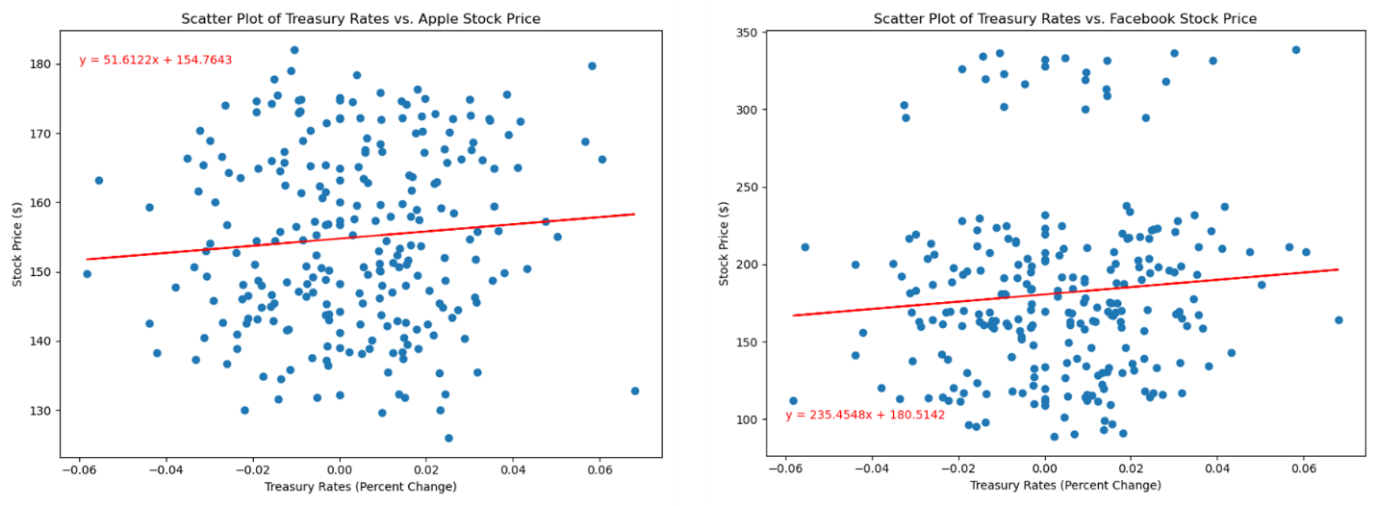 Using data from NASDAQ API, we found that the percent change in treasury rates had no correlation with stock prices, as seen in figures 3 and 4 below. We will continue to use Facebook and Apple as our examples in this report

Figure 4

Figure 3

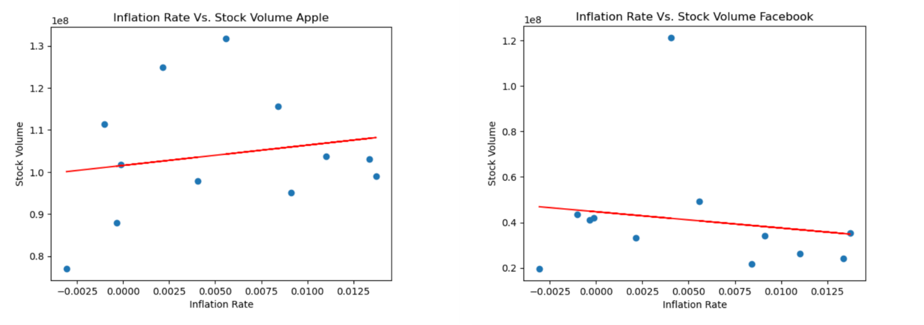The inflation rate, which is based on the CPI (consumer price index), did not have a correlation to stock price in 2022 as seen in figures 5 and 6 below.

Figure 5

Figure 6

In summary, we combined all five stock prices versus time data onto one graph below. In reference to figure 7 below, Apple appears to perform better than the other four FAANG stocks, because it had the lowest percentage decrease in stock price, from the start of the year to the end of the year.

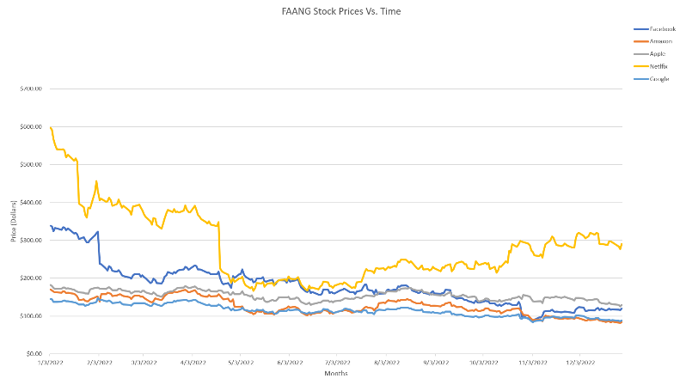

Figure 7